SECTION FA

CYLINDER HEADS AND VALVE GEAR

CONTENTS

Chapter

Removal and Dismantling .. .. .. .. .. .. .. 1

Inspection .. .. .. .. .. .. .. .. .. 2

Assembly and Fitting .. .. .. .. .. .. .. 3

Renewing Valve Seat Inserts and Valve Guides .. .. .. .. 4

Checking Bumping Clearances .. .. .. .. .. .. 5

Adjusting Tappet Clearances .. .. .. .. .. .. 6

Special Tools .. .. .. .. .. .. .. .. .. 7

CHAPTER 1

REMOVAL AND DISMANTLING

Removal

1. Drain engine cooling system (see Section KA).
2. Drain the fuel system (see Section GB).
3. Remove the setbolts securing the coolant outlet bends to the the cylinder heads and exhaust manifolds and remove the bends and 'O' rings, (see Section LC)
4. Slacken off the exhaust bellows clamp band nuts to release the pressure on the clamping segments, allowing the bellows to contract and draw away from the manifold. Release setscrews securing the bellows to each cylinder head and remove the bellows complete with joint rings.
5. Remove the fuel injector piping and fuel injectors (see Sections GH and GJ)
6. Release fuel return connections at fuel injection pumps. Release clips securing fuel return rails to air manifolds and remove the rails.
7. Remove 'Start Pilot’ supply piping from air manifolds, if fitted.
8. Remove bolts securing air inlet pipe to air manifold.
9. Remove bolts and washers securing the air manifolds to the cylinder heads and remove the manifolds and joints. The UPPER bolts pass through the cylinder head flange and screw into the manifold, whilst the LOWER bolts pass through the manifold flange and screw into the cylinder head.
10. Remove the three setbolts (10)(Fig FA.l) and two capscrews (16) securing each cylinder head cover (14) in position and remove the covers and joints.
11. Remove nuts (13) and washers and remove rocker brackets (2) and (11) complete with fulcrum pin and rocker levers (3) and (15). Lift out push rods and bridge pieces (4) and (6).
12. Remove the cylinder head lubricating oil drain ferrules by compressing each plunger into its body and withdrawing the ferrule complete with 'O' rings (Fig FA.2).
13. Using a 36 mm standard socket spanner release and remove the securing nuts, spherical washers, and bridge blocks from between adjacent cylinder heads. Release nuts in a diagonal sequence (Fig FA.8).
14. Using special 32 mm socket spanner (Chapter 7) release and remove the front and rear cylinder head securing nuts, plain and recessed washers and 'O' rings. Release nuts in diagonal sequence.
15. Remove the appropriate crankcase door and rotate the crankshaft to position the relevant crankpin at Vertical Top Centre (VTC).
16. Using liner clamp (Chapter 7), clamp the bottom of the cylinder liner to the crankcase as shown in Fig FA.3. Ensure that the pivoting head of the clamp engages with the recess in the crankcase.

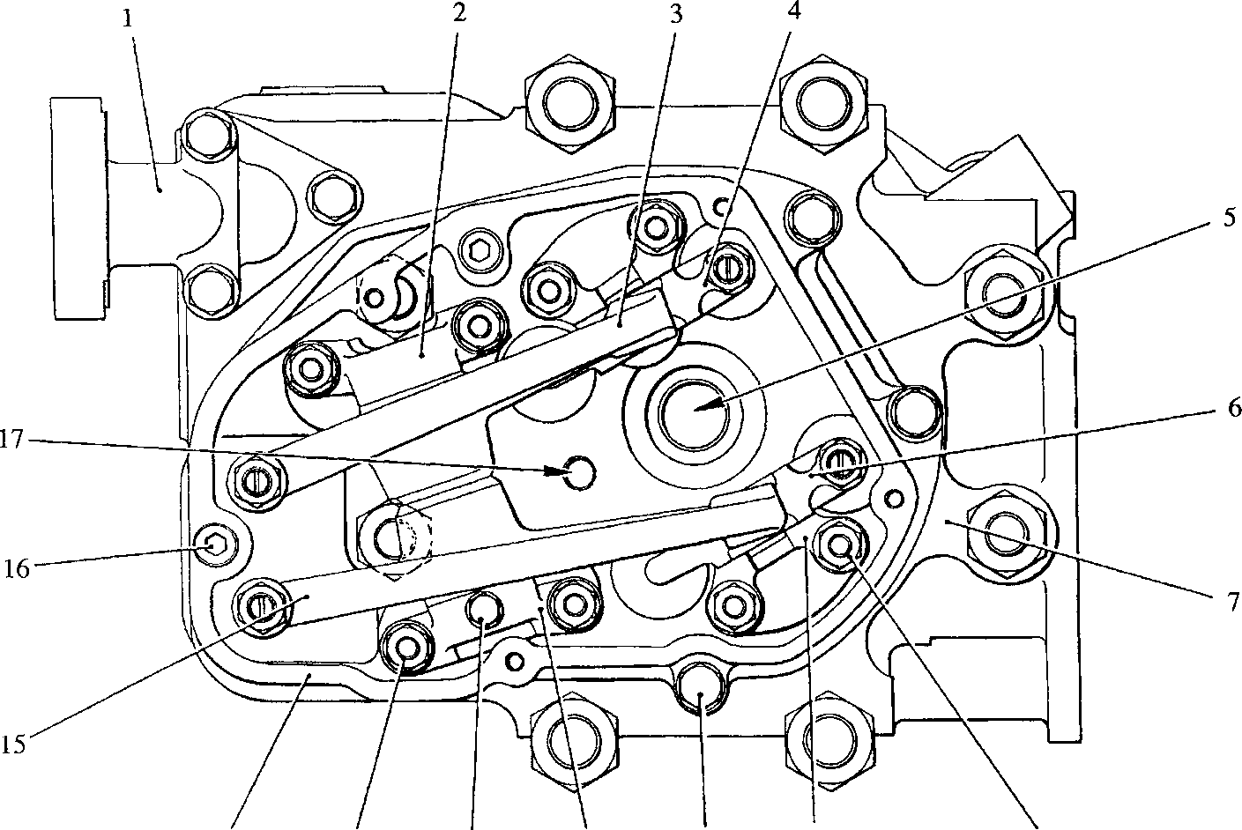Key To Numbers

13 12 11 10 9

SPD00174

1. Coolant outlet bend
2. Rocker fulcrum bracket - exhaust
3. Rocker lever - exhaust
4. Bridge piece
5. Injector housing
6. Bridge piece
7. Cylinder head
8. Nut securing bridge piece guide
9. Bridge piece guide
10. Bolt - cylinder head cover
11. Rocker fulcrum bracket - inlet
12. Locating screw - rocker fulcrum
13. Nut securing fulcrum brackets
14. Cylinder head cover
15. Rocker lever - inlet
16. Capscrew - cylinder head cover
17. Injector clamp bolt hole

Fig FA.l Plan view of cylinder head

1. Screw the lifting eyebolt assembly into the injector clamp bolt hole, ensuring that the face of the stand-off contacts the face of the cylinder head. Fit lifting tackle and apply tension.
2. Using a suitable lever between the cylinder head and crankcase at the position shown in Fig FA.4, rock the cylinder head to break the carbon seal between the cylinder head and liner. Due to the arrangement of locating ferrules, transfer ferrules and joints, only a limited movement is possible. Care must be taken not to disturb the cylinder liner.

CAUTION DO NOT ATTEMPT TO USE A LEVER AT ANY POSITION OTHER THAN THAT SHOWN

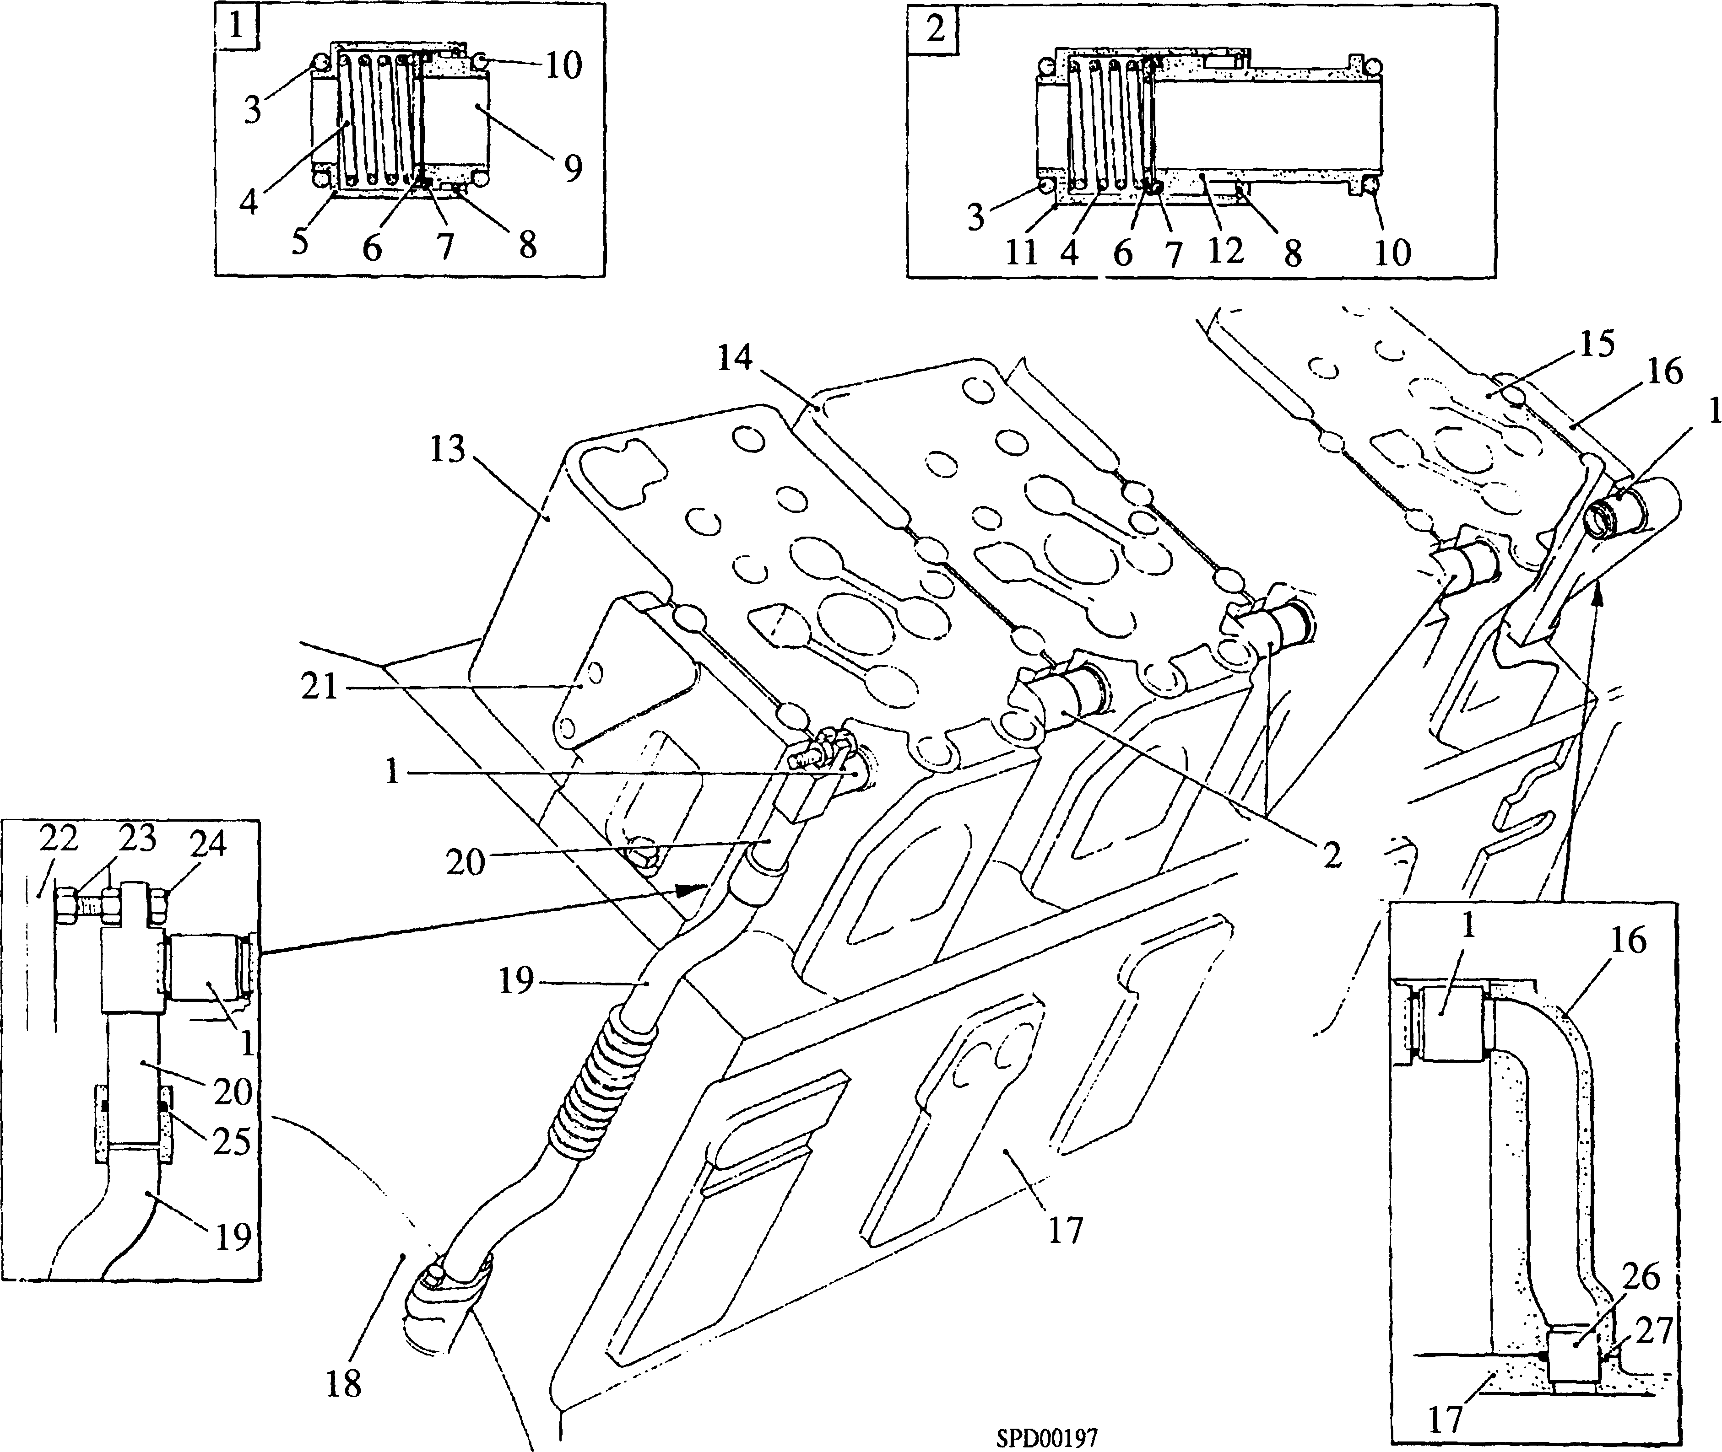

|  |  |  |  |
| --- | --- | --- | --- |
| Key To Numbers  1. Oil drain ferrule - short | | 15. | Drive-end cylinder head |
| 2. | Oil drain ferrule - long | 16. | Drive-end bridge block support |
| 3. | 'O' ring for body | 17. | Crankcase |
| 4. | Spring | 18. | Free-end cover |
| 5. | Body for item (1) | 19. | Free-end oil drain pipe |
| 6. | Spring carrier | 20. | Oil drain adaptor |
| 7. | 'O' ring, plunger to body | 21. | Free-end bridge block support |
| 8. | Circlip | 22. | Air delivery pipe (see Section LC) |
| 9. | Plunger for item (1) | 23. | Locknuts for item (24) |
| 10. | 'O' ring for plunger | 24. | Positioning setscrew for item (20) |
| 11. | Body for item (2) | 25. | 'O' ring, item (20) to (19) |
| 12. | Plunger for item (2) | 26. | Oil transfer ferrule head |
| 13. | Free-end cylinder head | 27. | 'O’ ring for item (26) |
| 14. | Intermediate cylinder head |  |  |

Fig FA.2 Arrangement of oil drain ferrules

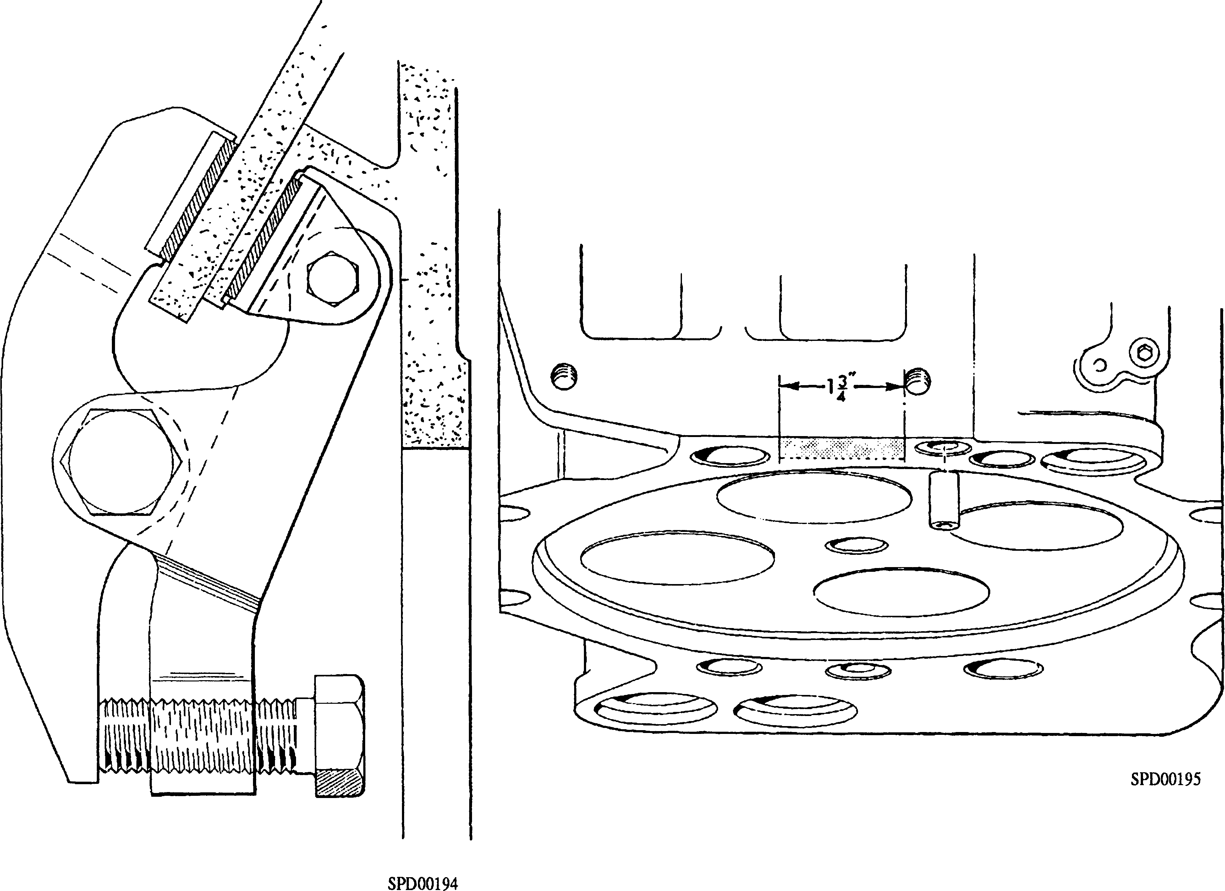

Fig FA.3 Cylinder liner clamp Fig FA.4 Position of lever for breaking

in position carbon seal

1. Lift the cylinder head clear of the engine and using two suitable pieces of wood as supports, place the head on a bench. DO NOT allow the cylinder head to rest on the combustion face as this will damage the push rod and fuel drain ferrules.
2. Remove lifting eyebolt and stand-off from the cylinder head and the liner clamp from the crankcase and repeat removal sequence for remaining cylinder heads.

Dismantling

1. Remove circlips (l)(Fig FA.5) from the valve spring carriers (3)
2. Assemble the valve spring compressing tool to the cylinder head and remove the valves as follows:-
3. Screw nut (12) on to the lower end of stud (13), place backing plate (11) in position and pass the stud through injector housing (14).
4. Place compression plate (5) in position on the spring carriers ensuring that the cutaways in the plate locate over the bridge piece guides (4).
5. Align the backing plate so that the corners of the plate cover the valve heads and fit thrust washer (7) and nut (6).

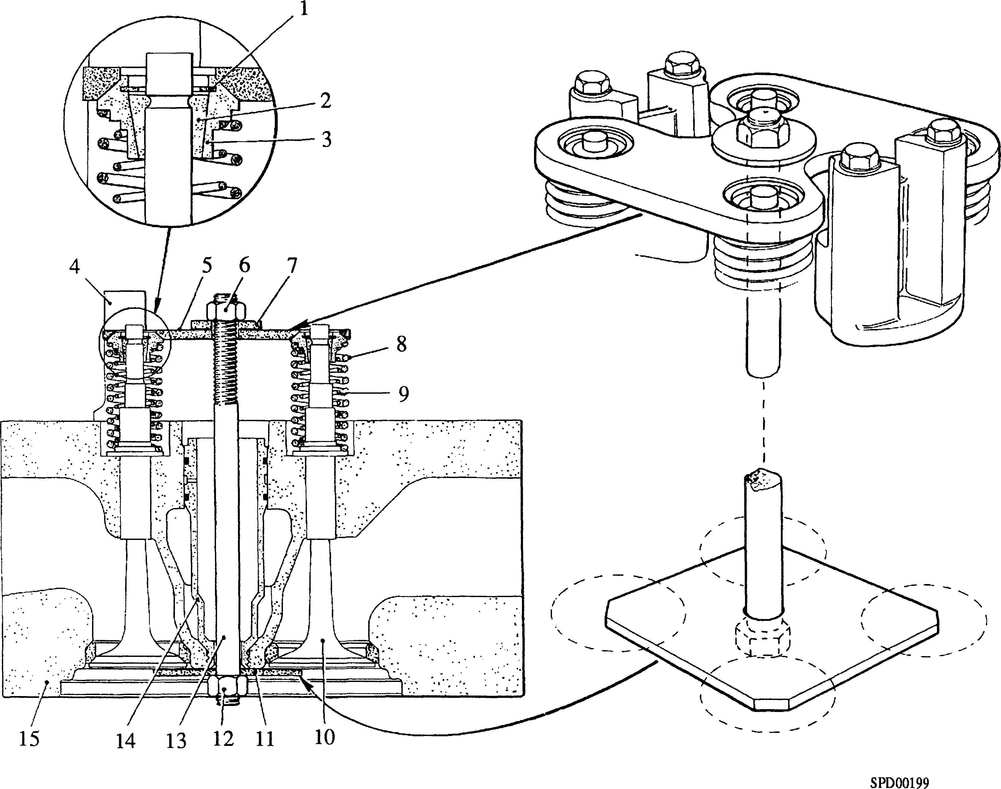

|  |  |  |  |
| --- | --- | --- | --- |
| Key To Numbers  1 Circlip | | 9 | Inner valve spring |
| 2 | Split collet | 10 | Valve |
| 3 | Spring carrier | 11 | Backing plate |
| 4 | Bridge piece guide | 12 | Nut |
| 5 | Compression plate | 13 | Stud |
| 6 | Nut | 14 | Injector housing |
| 7 | Thrust washer | 15 | Cylinder head |
| 8 | Outer valve spring |  |  |

Fig FA.5 Valve spring compressor in use

1. Tighten nut (6) sufficiently to exert a firm pressure on all the valve spring carriers (3) and using a hide mallet tap the compression plate at each spring carrier position to break the adhesion between the split collets and spring carriers.
2. Tighten nut (6) to compress the valve springs and remove split collets (2).
3. Release nut (6) and remove thrust washer (7), compression plate (5), spring carriers (3) and valve springs (8) and (9).
4. Invert the cylinder head and remove stud (13) and backing plate (11).
5. Remove the inlet and exhaust valves from the head. Check that the valves are identified for both position and head. If the valves are not identified this must be done so immediately on removal. The valves should be identified by ETCHING on that portion of the valve stem ABOVE the split collet recess. THE VALVES MUST NOT BE IDENTIFIED BY STAMPING.
6. Do not remove the injector housing from the cylinder head unless leakage has been observed. When removal is necessary, injector housing tool (l)(Fig. FA.6) should be used.
7. Remove the fulcrum shaft locating screw (12)(Fig FA.l) and spring washer from the inlet side fulcrum bracket (11), separate the brackets from the fulcrum shaft and remove the rocker levers. The fulcrum shaft is retained in position in the brackets with LOCTITE GRADE 290 and it will be necessary to tap the shaft out of the brackets with the aid of a soft drift.
8. To dismantle the lubricating oil drain ferrules, remove circlip (8)(Fig FA.2, inset 2) and withdraw plunger (12), 'O' ring (7), spring carrier (6), and spring (4). Both the long and short ferrules are identical in construction.

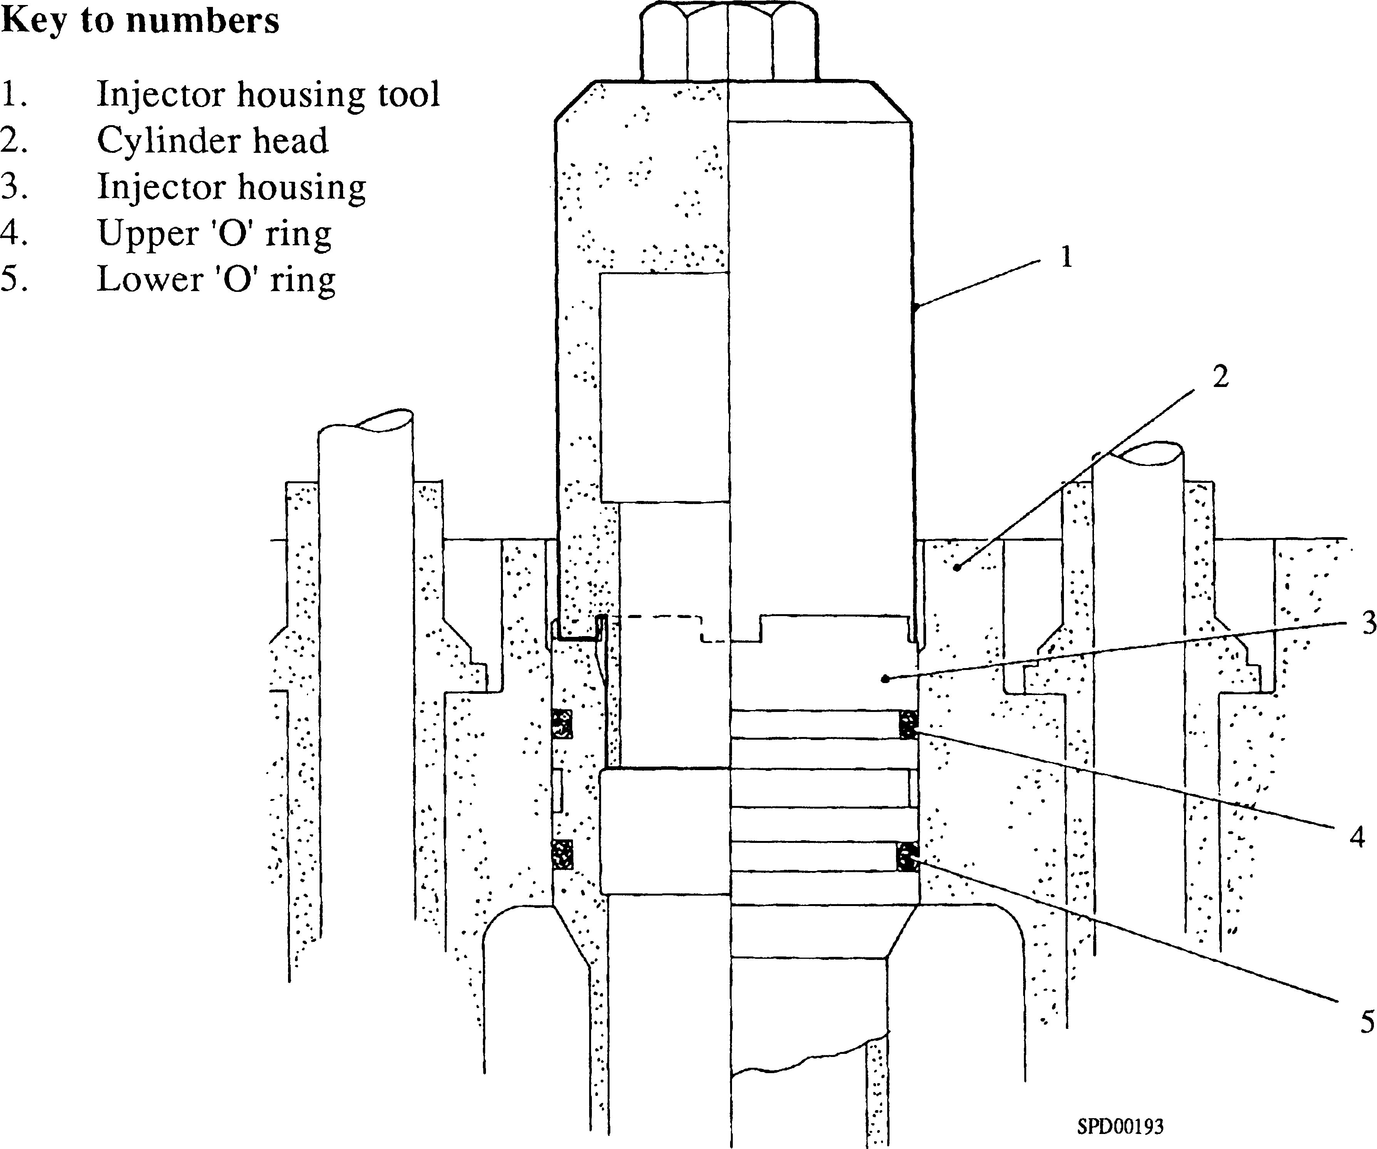

Fig FA.6 Injector housing removal and fitting

CHAPTER 2

INSPECTION

1. Where practicable, the dimensions of components should be checked against the figures given in the Schedule of Clearances and Wear Tolerances (Section CD).
2. Remove all traces of old jointing or ’LOCTITE' preparations and check all mating surfaces for blemishes likely to prevent a good seal.
3. Carefully check for signs of coolant leakage. Remove all carbon from the valves and valve seats and examine for burning, pitting, corrosion and indentation. Check that valve stems are not bent.
4. If the valves and seats are not badly marked they may be cleaned and bedded by lapping with fine carborundum paste. It must, however, be emphasised that both valves and seats are hardened and it may not be possible to clean them in this fashion, in which case valves must be refaced and seats recut as described below.
5. The valve seats are 'Valmet' heat resisting iron and are inserts shrunk into the cylinder heads. After re-cutting seats, place new valves in position in the cylinder head and with a straight edge across the combustion face and over the valves, measure the gap between the straight edge and the heads of the valves. If this figure exceeds the 'maximum depth' quoted in the Schedule of Clearances and Wear Tolerances, renew the valve seat inserts.
6. Valves should be refaced and seats recut using machine tools suitable for this type of work. We recommend the use of the following:-

The 'HUNGER' VKD2 VALVE REFACING MACHINE (power or hand operated). The 'HUNGER' VKD2/45/300 VALVE SEAT TURNING MACHINE.

These machines are manufactured by

LUDWIG HUNGER WERKZEUGFABRIK,

8000, MUNCHEN 55,

GRAFELINER STR. 146  
W. GERMANY

and obtainable in the United Kingdom from

MESSRS E.F. ALLCHIN & CO LTD.

EFACO HOUSE,

45 GREEN LANE,

BORDESLEY GREEN,

BIRMINGHAM 9.

The use of these machines will eliminate the necessity for lapping the valve to its seat, a light application of engineers blue being sufficient to verify seating contact.

1. If the valves are refaced and seats recut on machines other than those recommended above, the valve should be lapped to its seat with fine carborundum paste with the aid of the valve grinding tool (Chapter 7). After lapping, wash the valve and seat to remove all traces of the carborundum paste.
2. Examine the valve guide bores for scoring and check the clearance of the valve stem in the guide (this may be done with narrow feeler gauges).

NOTE If a new valve guide is fitted, the valve seat must be refaced to ensure

concentricity with the bore of the new guide.

1. Examine the valve springs for cracking and flaking of the protective coating.
2. Check the valve springs for fatigue. When new, the valve springs conform to the following:-

Inner Valve Springs

Free-length 3.019 in ± 0.038 in Fitted 40.42 lb @ 2.333 ins ± 5%

Open 96.3 lb @ 1.634 in ± 5%

Outer Valve Spring

Free-length 3.089 in ± 0.038 in Fitted 69.64 lb @ 2.565 ins ±5%

Open 181 lb @ 1.865 in ±5%

1. If the figures obtained on test after service are more than 2% below the minimum new tolerance, the springs must be renewed.
2. Examine the thrust faces of the fulcrum shaft brackets for scoring.
3. Check the fulcrum shaft for scoring and measure the diameter of the bearing surface. Check that the oilways in the shaft are clear.
4. Examine the bores of the rocker lever bushes for scoring and measure the bores. Examine the hardened toe of the levers for wear. Check the condition of the adjusting screw and locknut.
5. Check that the oilways in the adjusting screw and rocker lever are clear.

NOTE The oil hole in the rocker lever bushes cannot be drilled after fitting, and the bushes are therefore supplied pre-finished. When fitting new bushes care must be taken to ensure that the oil holes in the bushes and levers correspond.

1. Examine the bores and rubbing faces of the bridge-piece guides for scoring.
2. Examine the bridge-piece rubbing faces and guide columns for scoring and the hardened pad on the top face and the hardened toe for wear.
3. Check the bridge-piece adjusting screw and locknut for wear and serviceability.
4. If the injector housing has been removed, check for distortion or cracks. Remove any burrs caused during removal. Check the condition of the threads.
5. Check the condition of the injector clamp and clamping setbolt.
6. Check the push rods for straightness. Examine the hardened end pieces for wear and ensure that the oil holes are clear.
7. Check all studs, nuts and setbolts for serviceability.

CHAPTER 3

ASSEMBLY AND FITTING

NOTE All joints and 'O' rings must be fitted without the use of jointing compound. A smear of petroleum jelly may be used to retain joints and 'O' rings in position during fitting.

1. The following procedure is based on the assumption that the cylinder heads have been completely dismantled and the injector housing removed.

Assembly

1. Fit new valve guides and valve seat inserts (Chapter 4).
2. Check that the injector housing is seating correctly in the cylinder head. This is necessary as slight distortion of the cylinder head may occur in service. The check should be carried out as follows:-
3. Apply marking blue to the injector housing lower seat facing and using tool (l)(Fig FA.6), screw the housing into position in the head and tighten firmly 'hand tight' DO NOT use a spanner.
4. Unscrew and remove the injector housing and check that it is seating correctly, i.e. has all round contact on the facing.
5. If the housing is not seating correctly, the seat in the cylinder head must be trued up with a 45° cutter and a further check carried out.

NOTE DO NOT fit an 'O' ring to the centre groove of the housing as this forms part of the fuel leak-off system for the fuel injector.

1. When a satisfactory seating is obtained, degrease the threads and seating of both injector housing and cylinder head with LOCTITE SAFETY SOLVENT or other chlorinated solvent, allow to dry and coat the threads and seating face of the housing with LOCTITE GRADE 275.
2. Fit new 'O' rings (4) and (5) to the top and bottom injector housing grooves and coat the rings with petroleum jelly.
3. Screw the injector housing into the cylinder head and using tool(l)(Fig FA.9) tighten to the torque loading quoted in Section CE. Allow approximately 3 hours for the LOCTITE to 'cure'.
4. Water test the cylinder head, raising the pressure in the head to 60 lb.f/in2 (4.2 kg.f/cm2) and maintain for a period of 20 minutes. Check for water leakage from around the injector housing threads and past the lower 'O' ring (5). Leakage past the 'O' ring will be shown by water draining from the fuel drain drilling.
5. Fit a fuel injector (Section GH) to the head. Connect a controlled air supply to the fuel injector leak-off drilling, raise the pressure to 20 lb.f/in2 (1.4 kg.f/cm2) and check for leakage past the injector housing upper 'O' ring (4). A small quantity of lubricating oil poured into the gap between the injector housing and head will show any air leakage. Remove test equipment and fuel injector.
6. Fit the bridge-piece guides (9)(Fig FA.l) and secure with plain washers and philidas nuts (8). Tighten the nuts to the torque loading quoted in Section CE.
7. Place the valves in position (see Chapter 2 regarding refacing valves and seats). New valves must be identified (see Chapter 1 paragraph 1.23).
8. Assemble backing plate (ll)(Fig FA.5) and centre stud (13) of the valve spring compressing tool to the cylinder head. Place the valve springs (8) and (9) and spring carriers (3) in position, fit compression plate (5), thrust washer (7) and nut (6).
9. Check that the corners of the backing plate cover the valve heads and tighten nut (6) to compress the springs. Fit the split collets (2), remove the tool and fit retaining circlips (1).
10. Degrease the rocker lever fulcrum shaft and the bores of the fulcrum brackets with LOCTITE SAFETY SOLVENT or a suitable chlorinated degreasant and allow to dry. Smear a light film of LOCTITE GRADE 290 in the bore of inlet side fulcrum bracket (ll)(Fig. FA.l), tap the fulcrum shaft into position, fit locating screw (12) together with a spring washer and tighten.
11. Press new bushes into the rocker levers. Ensure that the drillings in the bushes and rocker levers are correctly aligned before fitting. The bushes are pre-finished to the correct size when pressed into position.
12. Fit rocker levers (15) and (3) to the fulcrum shaft. It should be noted that the inlet rocker lever (15) is the longer and should be fitted first.
13. Smear a light film of LOCTITE GRADE 290 in the bore of the exhaust side fulcrum bracket (2) and tap the bracket on to the shaft. Use a 0.010 in (0.254 mm) feeler gauge between the rocker levers to maintain the necessary end clearance. Ensure that the feet of both brackets are parallel.

NOTE Ensure that LOCTITE GRADE 290 does not come into contact with the bearing surfaces.

1. Assemble the oil drain ferrules as follows (Fig FA.2, inset 2):-
2. Place spring (4) and spring carrier (6) in position in body (11). Fit a new 'O' ring (7) to plunger (12), insert into body (11) and fit circlip (8). Repeat for two short ferrules (inset 1).
3. Fit the transfer and locating ferrules to the cylinder head and crankcase as follows:-
4. Degrease the transfer and locating ferrules, and their bores in the cylinder heads and crankcase with LOCTITE SAFETY SOLVENT or a suitable chlorinated solvent, and allow to dry.
5. Coat the engaging portions of the coolant transfer ferrules (3) and (8)(Fig FA.7) and locating ferrules (5) with 'LOCTITE GRADE 648' and insert into the crankcase to the full depth of the drilling.
6. Coat the engaging portion of fuel drain ferrule (1) with 'LOCTITE GRADE 648' and insert into the cylinder head to the full depth of the drilling.
7. Coat the engaging portions of the push rod aperture ferrules (13) with 'LOCTITE GRADE 648' and insert into the head allowing 3/8 in (9.5 mm) protrusion from the face of the head. Bend over the locking tabs on the ferrules.
8. Allow approximately 3 hours for the 'LOCTITE' to cure.

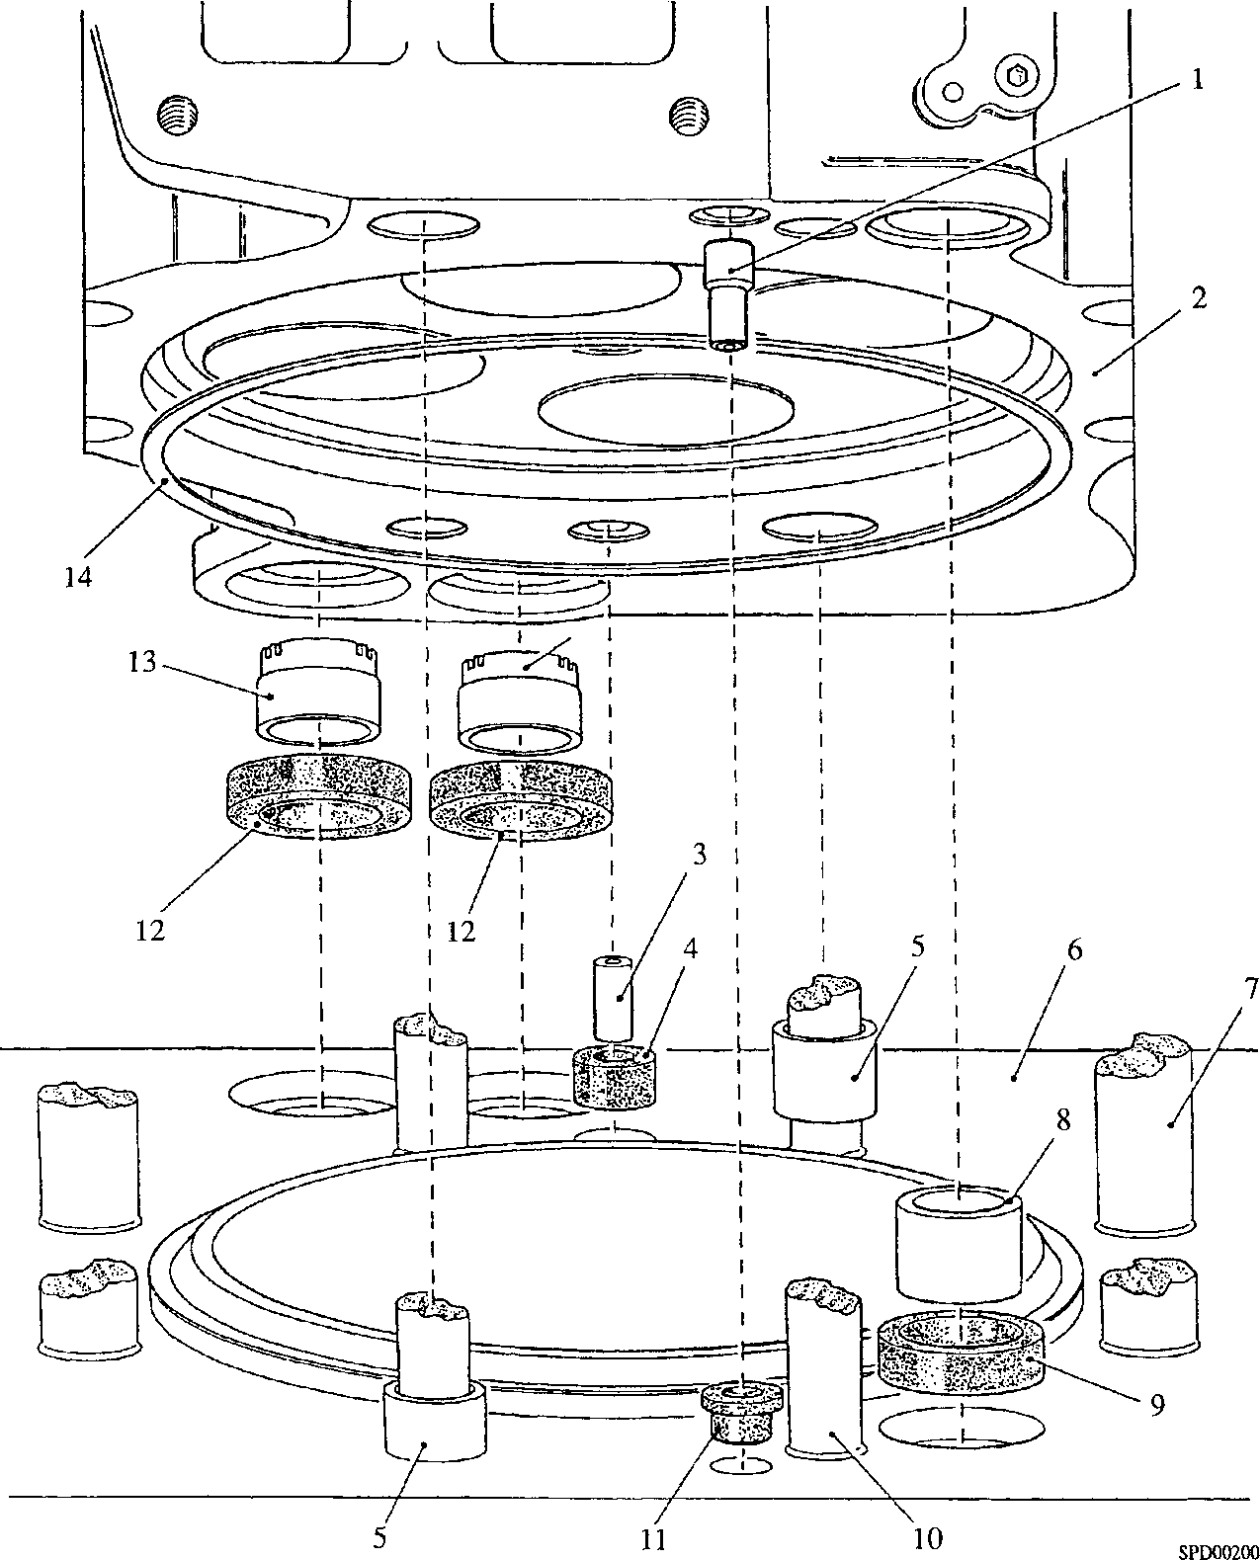Fig FA.7 Positions of locating, coolant transfer and fuel drain ferrules and joint rings

Key To Numbers

1. Fuel drain ferrule
2. Cylinder head
3. Coolant transfer ferrule -small
4. Joint ring for item 3
5. Cylinder head locating ferrule
6. Crankcase
7. Cylinder head stud - large
8. Coolant transfer ferrule - large
9. Joint ring for item 8
10. Cylinder head stud - small
11. Joint ring for item 1
12. Joint ring for item 13
13. Push rod aperture ferrules
14. Joint - cylinder head to liner

Coat the transfer ferrule joints with soft soap or petroleum jelly and fit to the ferrules and ferrule apertures in the crankcase.

Fitting

3.14

3.15

3.16

3.17

3.18

3.19

3.20

3.21

3.22

3.23

3.24

3.25

NOTE 1 The joint rings are copper plated steel rings

1. When replacement components such as connecting rods, pistons or liners have been fitted, the 'Bumping Clearance' must be checked (Chapter 5).

Fit new cylinder head joint rings of the same thickness as the ones removed.

Screw the lifting eyebolt assembly into the injector clamp bolt hole ensuring that the face of the stand-off contacts the face of the head. Using suitable lifting tackle, fit the cylinder heads, ensuring that the ferrules and joints are correctly located.

NOTE Each cylinder head has a movement of approximately 0.4 mm on its location.

Using a suitable straight edge across the cylinder head air inlet facings, check that all heads are in alignment.

NOTE The smaller nuts at the front and rear of the heads must be tightened to their full torque loading before the larger nuts are tightened.

Fit 'O' rings (8)(Fig FA.8), recessed washers (6) and capnuts (7) to the rear cylinder head studs (9) and recessed washers (11) and nuts (10) to the front cylinder head studs (12). Using special socket spanner (Chapter 7) 'nip-up' all nuts and re-check alignment. Tighten the nuts, a little at a time, in the sequence indicated (1, 2, 3, 4) until the full torque loading quoted in Section CE is attained. Re-check head alignment.

Fit bridge blocks (3), spherical washers (2) and nuts (1) to the side cylinder head studs (4). Fit bridge block alignment tool (5) and using a socket spanner tighten the nuts, a little at a time, in the sequence indicated (W, X, Y, Z) until the full torque loading quoted in Section CE is attained.

Fit tappet adjusting screws and philidas thin nuts to the rocker levers and bridge pieces.

Engage the bridge piece guide columns with the bores in the bridge piece guides, positioning the bridge pieces with the tappet adjusting screws towards the inlet (front) side of the head.

Place the push rods in position. Check that the ball-ends of the push rods engage with the cups in the cam followers. When engaged, no side movement will be detected.

Bar the crankshaft round to place the piston of the cylinder concerned at TDC compression stroke. Fit the rocker lever assembly and 'nip-up' the securing nuts. Check that bracket is seating squarely on the cylinder head and that there is clearance at both rocker levers.

Tighten the securing nuts to the torque loading quoted in Section CE. Adjust tappet clearances as detailed in Chapter 6.

Using new 'O' rings (3) and (10)(Fig FA.2), fit the lubricating oil drain ferrules between the cylinder heads, and the end heads and supports or drain tubes.

Key to Numbers

A Assembly of side cylinder head nuts and studs

B Assembly of rear cylinder head nuts and studs

C Assembly of front cylinder head nuts and studs

FA.8 Arrangement of cylinder head securing nuts and tightening sequence

Fig

3.26

3.27

Coat the 'O' rings for the coolant outlet bends with soft soap or petroleum jelly, fit to the recesses in the bend faces and secure the bends to the cylinder heads and exhaust manifolds with setbolts and spring washers.

Using new joints, fit the air manifolds to the cylinder heads with setbolts and plain washers (Section LC). The UPPER bolts pass through the cylinder head flange and screw into the manifold whilst the LOWER bolts pass through the manifold flange and screw into the cylinder head.

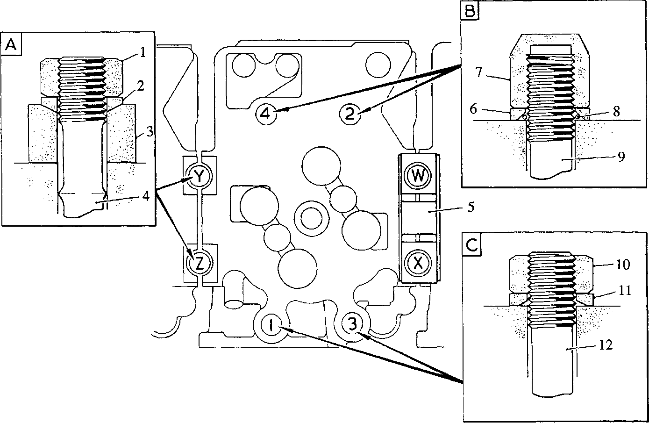Connect air piping between charge air heater/cooler and manifold.

3.28

|  |  |  |  |
| --- | --- | --- | --- |
| 1 | Plain nut | 7 | Capnut |
| 2 | Spherical washer | 8 | 'O' ring |
| 3 | Bridge block | 9 | Stud |
| 4 | Stud | 10 | Plain nut |
| 5 | Bridge block alignment tool | 11 | Recessed washer |
| 6 | Recessed washer | 12 | Stud |

SPD00198

1. Using new joints, fit the cylinder head covers. Each cover is secured by three setbolts (10)(Fig FA.l), and two capscrews (16). Plain washers are fitted beneath the setbolt heads.
2. Fit 'Start Pilot’ supply piping, if fitted.
3. Fit fuel return rails and connect to fuel injection pumps.
4. Fit fuel injectors and fuel injection piping (Section GH and GJ).
5. Clip piping to air inlet manifolds.
6. Using new joints, fit the valve gear covers and secure with setscrews and plain washers.
7. Prime and vent the fuel and coolant systems (Section DA).

CHAPTER 4

RENEWING VALVE SEAT INSERTS

1. Completely strip the cylinder head, removing studs, old jointing etc, etc., likely to interfere with machining operation.
2. Press out the valve guides.
3. Machine the existing inserts (see dimensions Fig FA.9) until they become thin shells and carefully prise out, taking care not to damage the recesses. Where suitable machine tools are not available to undertake this work, the use of the HUNGER Insert Turning Apparatus 'RDS 2' is recommended. This tool is obtainable from addresses stated in Chapter 2.
4. Inspect the recess faces for damage; clean up if necessary. Do not rework the recess face unnecessarily as this will reduce the interference fit between the insert and the head.
5. Degrease the recesses in the cylinder head using LOCTITE SAFETY SOLVENT or a suitable chlorinated solvent.
6. Degrease the new inserts as described above and check that they are free from damage or marks likely to cause obstruction when they are pressed into the cylinder head.
7. Place the inserts in a bath of liquid nitrogen. The temperature of liquid nitrogen is -196°C, when the insert is placed in the bath the solution will boil and will continue to do so until the insert assumes the temperature of the bath.

WARNING DO NOT USE LIQUID OXYGEN OR LIQUID AIR FOR FREEZING. MOST PARTS WILL HAVE TRACES OF LUBRICATING OIL OR PRESERVATIVE OIL REMAINING ON THEM. A MIXTURE OF OIL AND EITHER LIQUID OXYGEN OR LIQUID AIR IS LIABLE TO CAUSE AN EXPLOSION.

1. Ensuring that the recess in the cylinder head is clean, place each insert in position. With the locating shaft of valve seat dolly (Chapter 7) positioned in the bore for the valve guide in the cylinder head, centralise each insert in its recess with a light hammer tap on the top of the drift and then apply a sharp blow to drive the insert home.
2. Degrease valve guides and valve bores in the cylinder head using LOCTITE SAFETY SOLVENT or a suitable chlorinated solvent.
3. Place the valve guides in a bath of liquid nitrogen and leave until the guides assume the temperature of the bath, i.e. until boiling ceases.
4. Engage the guides with the cylinder head bores and press into position.

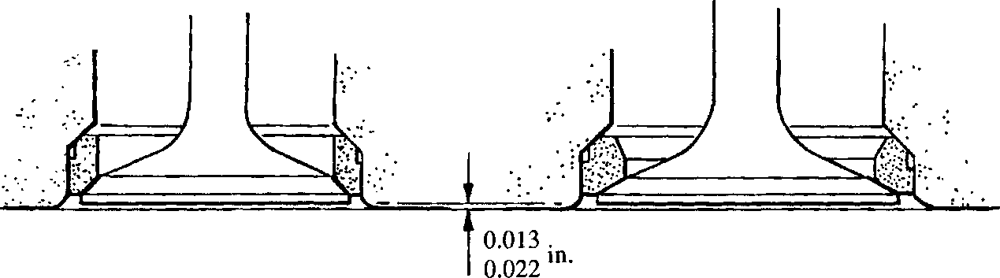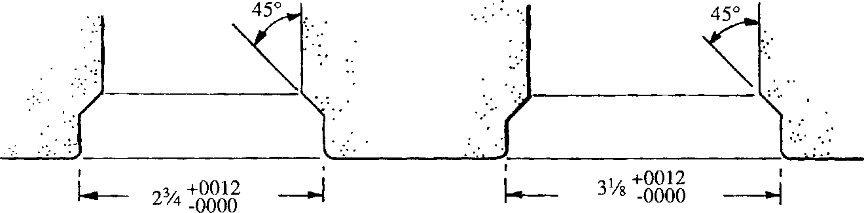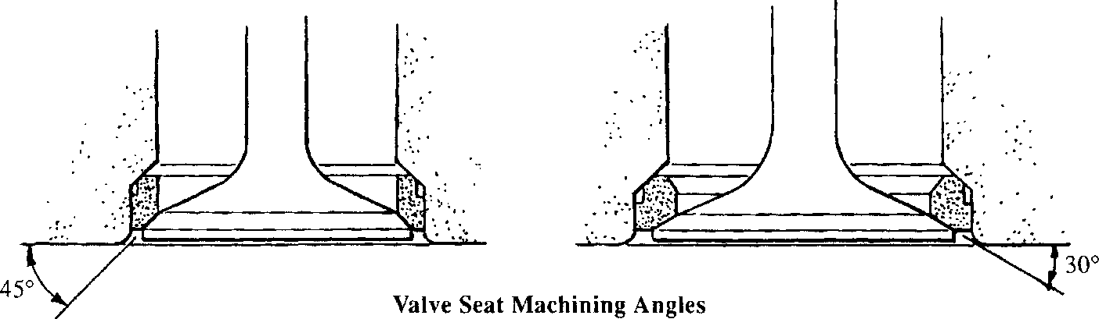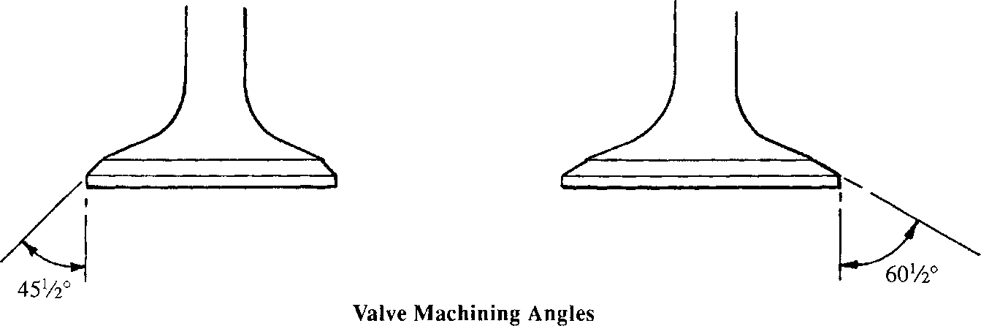EXHAUST INLET

**EXHAUST**

Valve Seat Depth

**INLET**

Valve Recess Dimensions

**EXHAUST**

**INLET**

**EXHAUST INLET**

SPD00175

Fig FA.9 Machining dimensions for valve seat recesses and inserts

Fit new valves and measure the distance between the valve face and the combustion face of the head. Reference to Fig FA.9 will indicate the depth to which the seat must be cut. The HUNGER tool quoted in Chapter 2 should be used.

NOTE The figures quoted for 'depth of valve below head face' in the Schedule of Clearances and Wear Limits (Section CD) differ from those shown in Fig FA.9. The figures quoted in the Schedule are the Design Limits. The figures shown in Fig FA.9 are MACHINING LIMITS for new valve seat inserts when using a new valve as a gauge. These figures allow for the manufacturing tolerances of the valve and ensure that, after machining, ANY new valve fitted to that insert will be within the designed limits.

CHAPTER 5

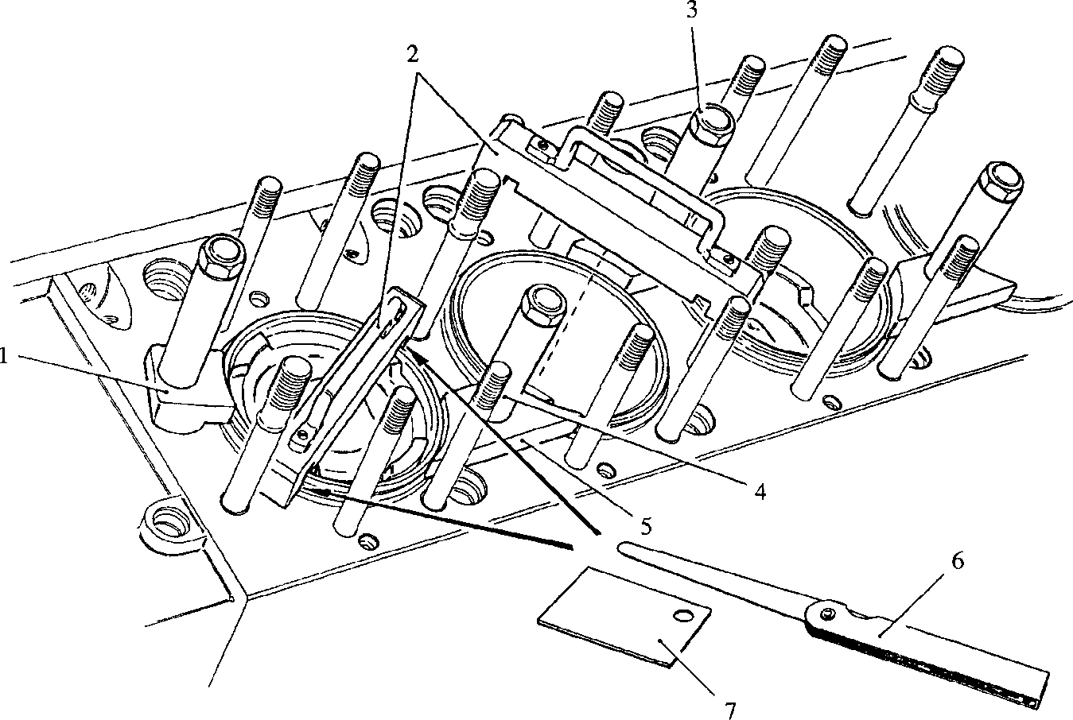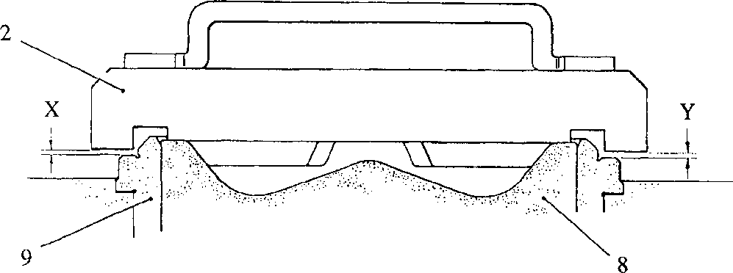CHECKING BUMPING CLEARANCE

Feeler gauge Slip gauge Piston

Cylinder liner

Key To Numbers

1. End clamp 6
2. Bumping clearance gauge 7
3. Cylinder head nut 8
4. Distance piece 9
5. Centre clamp

Fig FA.10 Bumping clearance tool in use

1. The clearance between the top face of the piston and the underside of the cylinder head is referred to as the 'Bumping Clearance' and is controlled by the thickness of the copper plated steel joint ring fitted between the top flange of the liner and the cylinder head. This clearance is important and it is essential that it is checked if replacement components such as connecting rods, pistons or liners are fitted.
2. To check the clearance, proceed as follows (Fig FA. 10):-
3. Secure the cylinder liners (9) to the crankcase with end clamps (1), centre clamps (5) and distance pieces (4), securing them in position with cylinder head nuts (3). The clamps engage with the flange at the top of the liner. Tighten cylinder head nuts (3) to 200 Nm (150 lb.ft)

NOTE It is essential that the liners are firmly clamped to prevent the water jacket 'O' rings holding them off their seats and giving a false reading.

1. Bar the engine round to bring the appropriate piston (8) to T.D.C.
2. Centralise the piston in its bore, using feeler gauges between the piston and liner.
3. Place bumping clearance gauge (2) in position, so that it rests on two of the raised faces of the piston and measure the gap between the gauge and the liner flange with feeler gauges (6) and slip gauge (7) at two diametrically opposite positions.
4. Repeat for all cylinders.
5. All readings should be between 1.75 mm (0.069 in) minimum to 2.26 mm (0.089 in) maximum. Using the correct 2.64 mm (0.104 in) thick joint ring, this will give a 'Bumping Clearance ' of 2.79 - 3.30 mm (0.110 - 0.130 in).
6. If the gauge reading is less than 1.75 mm (0.069 in), check that the cylinder liners are correctly clamped down and that the piston concerned is accurately set at T.D.C.

CHAPTER 6

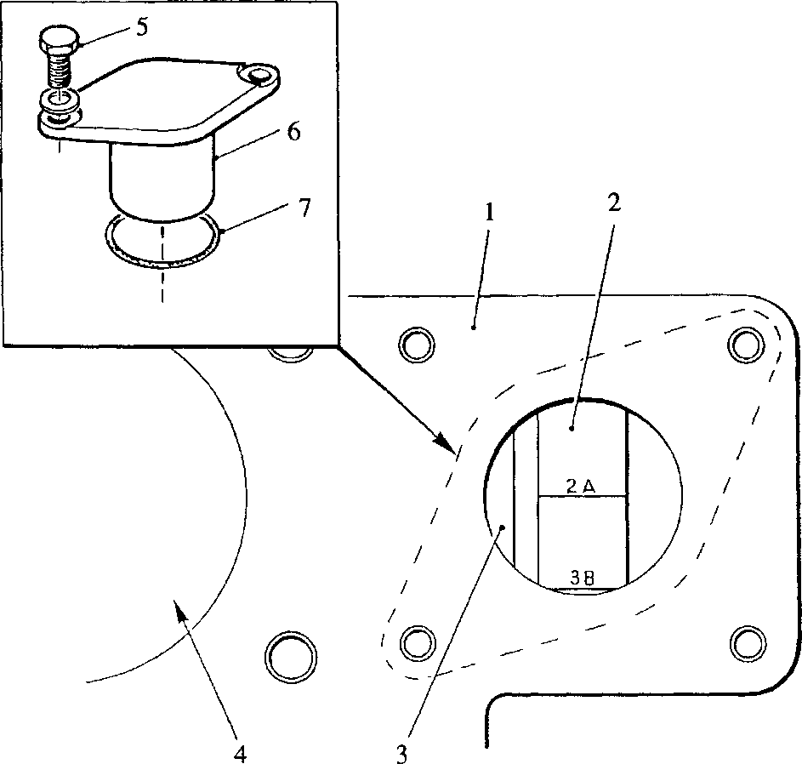ADJUSTING TAPPET CLEARANCES

Key To Numbers

1. 'A' bank fuel injection pump cambox
2. Securing setscrew
3. Blanking plug
4. 'O' ring
5. Tappet adjustment indicator
6. Fuel injection pump camshaft
7. Fuel injection pump mounting aperture

Fig. FA.ll Tappet adjustment indicator

1. Incorrect tappet clearances have an adverse effect on engine performance and it is therefore essential that the correct clearances should be maintained.
2. The tappet clearance for the valves of a cylinder should be set with that piston at T.D.C. compression stroke as indicated by the T.D.C. indicator (Fig FA.ll). The correct tappet clearance is quoted in Section CB.
3. To set the clearances proceed as follows:-
4. Remove securing setscrews (5)(Fig FA.ll) and remove blanking plug from 'A' bank fuel injection pump cambox to expose tappet adjustment indicator (2) mounted at the free-end of 'A' bank fuel injection pump camshaft (3)(see Section GG, Fig GG.l).
5. Remove valve gear covers.
6. Bar the engine round until the incised line for the cylinder concerned is at mid position in the cambox aperture.

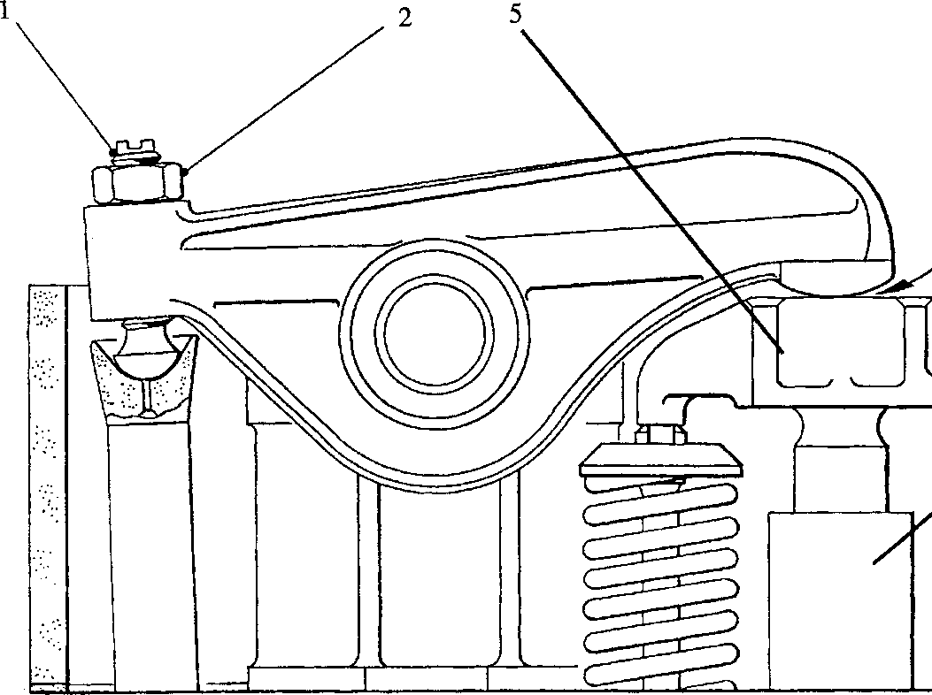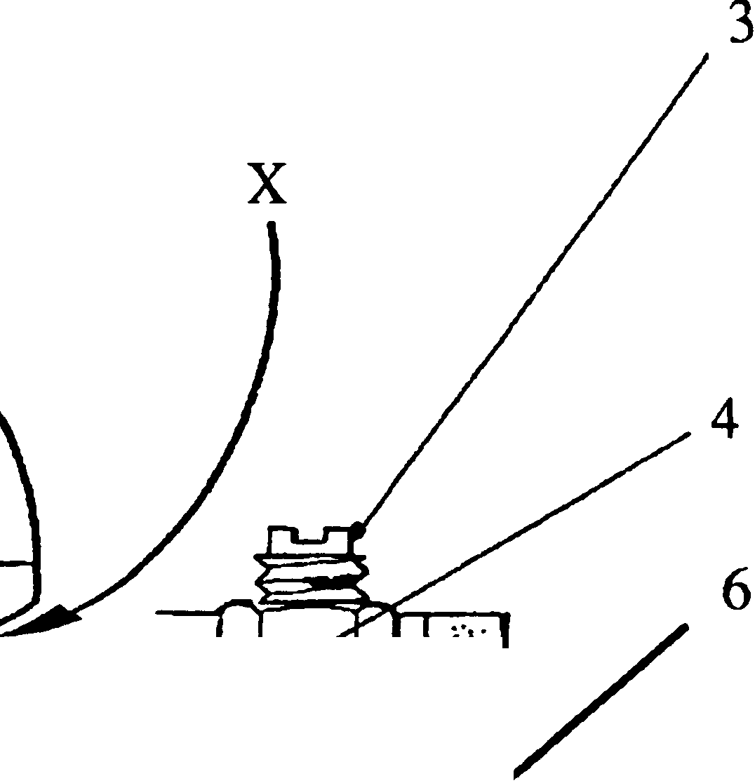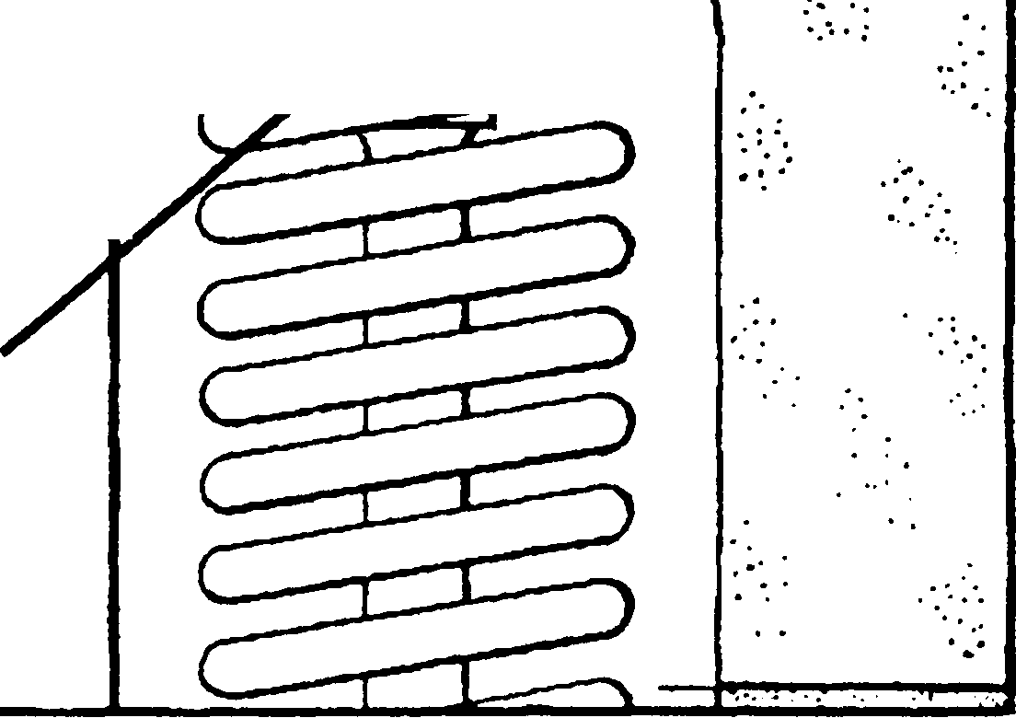SPD00201

CL

|  |  |  |
| --- | --- | --- |
|  |  | \ |
| l / |  |  |
|  | |  |
|  | |  |

Key To Numbers

'X' position for feeler gauge

1. Rocker lever tappet screw 3 Bridge piece tappet screw
2. Locknut 4 Locknut

Fig FA. 12 Tappet Adjustment

1. Insert special feeler gauge at position 'X' (Fig FA. 12), i.e. between the rocker lever and bridge piece on either the inlet or exhaust pair of valves.
2. Screw down adjusting screw (1) until a light restraint is felt on the feeler gauge, tighten locknut (2) and re-check the restraint on the feeler gauge.
3. Retaining the feeler gauge at position 'X', screw down adjusting screw (3) until a further restraint is felt on the feeler gauge, tighten locknut (4) and re­check the restraint.
4. Repeat for the remaining pair of valves.

NOTE Care must be taken when tightening the locknuts not to move the adjusting screws or to strain the threads by overtightening the locknuts.

1. Set clearances for all cylinders, barring the engine round to bring each piston to T.D.C. compression stroke as shown by the T.D.C. indicator.
2. When all clearances have been set, refit valve gear covers and cambox blanking plug. Check condition of cover joints and blanking plug 'O' ring (7)(Fig FA. 11) when re-fitting.

CHAPTER 7

SPECIAL TOOLS

The following special tools are sufficient for carrying out all general maintenance, dismantling, overhaul and assembly operations on the cylinder head as detailed in this section.

NOTE These tools are only shown in the Illustrated Parts List if they if they have been ordered as part of the contract.

|  |  |  |
| --- | --- | --- |
| DESCRIPTION | PART NO | USE |
| Torque Wrench: 10 to 50 lb.ft  Vi in square drive | OD 26977 | To tighten retaining nuts to a pre­determined loading |
| Torque Wrench: 50 to 250 lb.ft V2 in square drive | OD 28465 | To tighten retaining nuts to a pre­determined loading |
| Torque Wrench: 300 to 750 lb.ft 1 in square drive | OD 17846 | To tighten retaining nuts to a pre­determined loading |
| Socket Spanner, 36 mm | OD 28371/05 | To remove and tighten the large cylinder head nuts |
| Extension,  1 in square drive x 8 in long | OD 17845P2 | For releasing cylinder head securing nuts |
| Adaptor  1 in square drive x 3 in long | OD 17845P3 | For releasing cylinder head securing nuts |
| Bar handle,  30 in long xl Vs in dia | OD 17845P4 | For releasing cylinder head securing nuts |
| Socket Spanner,  32 mm A/F x 3/4 in square drive | Y3J70871 | To remove and tighten the small cylinder head nuts |
| Drive Converter, having 1 in square socket and V4 in square drive plug | OD28466/01 | To provide drive conversion between Torque Wrench (OD 17846) and Socket spanner (Y3J70871) |
| Injector Withdrawing Tool | Y3J70030 | To withdraw fuel injector from the cylinder head |
| Clamp cylinder liner to crankcase | Y3J70901 | To clamp lower end of cylinder liner to prevent liner movement during cylinder head removal |
| Eyebolt | OD28484 | To provide a lifting point for cylinder head removal and fitting |
| Stand-off for eyebolt | Y3J70084 | To raise lifting eyebolt clear of valve springs |
| Valve spring compressing tool | Y3J70502 | To compress the valve springs to enable the split cotters to be removed and fitted |
| Injector housing tool | Y3J70560B | Tool for removing and fitting injector housing |

|  |  |  |
| --- | --- | --- |
| DESCRIPTION | PART NO | USE |
| Valve Refacing Machine | OD28485 | 'HUNGER' machine VKD2 for refacing the seating at the correct angle on inlet and exhaust valves |
| Valve Seat Cutter | OD28486 | 'HUNGER' machine VD2/45/30 for cutting the valve seat inserts at the correct angles for inlet and exhaust valves |
| Valve Grinding Tool | Y3J70501 | To enable the valves to be lapped to their seats using carborundum paste when machines OD28485 and OD28486 are not available |
| Bridge Block Alignment Tool | YJ70614 | To maintain the correct alignment of the cylinder head bridge blocks when tightening the large cylinder head nuts |
| Inlet Valve Seat Insert Dolly | BT2224/3 | To fit inlet valve seat insert to cylinder head |
| Exhaust Valve Seat Insert Dolly | BT2224/3 | To fit exhaust valve seat insert to cylinder head |
| End Liner Clamp | YJ70334B.P3 | )  ) To clamp cylinder liners to crankcase |
| Centre Liner Clamp | YJ70334B.P4 | ) top face when checking 'Bumping ) Clearances' |
| Distance Pieces | Y3J70865 | ) |
| Bumping Clearance Gauge | Y3J70334 | To measure the 'Bumping Clearance' |
| Slip Gauge | Y3J70952 | A 0.062 in (1.575mm) slip gauge used in conjunction with std feeler gauge set to measure 'Bumping Clearances' |
| Special Feeler Gauge | Y3J70072 | A 0.005 in (0.127 mm) feeler gauge fitted with a right angled extension rod for setting tappet clearance (inlet valve) |
| Special Feeler Gauge | Y3J70072A | A 0.020 in (0.508 mm) feeler gauge fitted with a right angled extension rod for setting tappet clearance (exhaust valve) |